Saint Louis County Housing-related Coordinated Entry System
Contents
What is a Continuum of Care (CoC)? 3
What is Permanent Supportive Housing? 3
What is Transitional Housing? 4
What is Coordinated Entry (CE)? 4
What is a VI-SPDAT? 4
Saint Louis County Coordinated Entry (CE) 4
1. Pre-screen 4
2. VI-SPDAT 5
3. Waiting period 5
4. Placement 5
Identifying Eligible Residents 5
Filling out the SLCHAT Pre-Screen Contact Form 5
Name 6
Phone 6
Zip Code 6
Contact type 6
Where is the applicant spending the night at this time? 6
Residency 6
Where is the applicant spending the night at this time? 6
How long has the applicant been staying there? 6
Why is the applicant seeking transitional housing? 6
Domestic Violence 7
How old is the head of household 7
Household type 7
Number of people in household 7
Military veteran in household 7
Appointment Information 7
Worker’s Comments 7
Example Contact Form: 8
Downloading form 10
Setting an Appointment 11
Agencies with VI-SPDAT-trained case managers currently accepting CE appointments: 12
Duluth 12
Nett Lake 12
Virginia 12
Hibbing 12
Agencies with VI-SPDAT-trained case managers not currently accepting CE appointments: 12
Duluth 12
Hibbing 12
Virginia 12
Setting Client Expectations 12
Missed Appointments 13
Complaint Process 13
Contacts 13
Iron Range CoC Contacts 13
Legal Aid of Northeastern Minnesota 13
Range Transitional Housing 13
AEOA 13
Range Mental Health 13
Bois Forte 13
Duluth CoC Contacts 13
Duluth HRA 13
CHUM Homeless Shelter 14
Saint Louis County Public Health and Human Services 14
Duluth Street Outreach Team 14
MACV 14
Life House 14
Salvation Army 14
Maps of Saint Louis County Assessor Cities 14
South Saint Louis County - Duluth 14
North Saint Louis County – Hibbing, Nett Lake, Virginia 15

What is a Continuum of Care (CoC)?
A Continuum of Care (CoC) is a program designed to promote the goal of ending homelessness. This is done by providing funding for efforts by state and local governments as well as nonprofit providers in order to quickly rehouse homeless individuals and families. In Minnesota there are 10 CoCs. Most organizations operating housing units with state funding are required to participate in a designated Coordinated Entry process to fill those units. The type of units included in the Saint Louis County CoC’s Housing Related Coordinated Entry program include Permanent Supportive Housing (PSH) and Transitional Housing (TH) units.
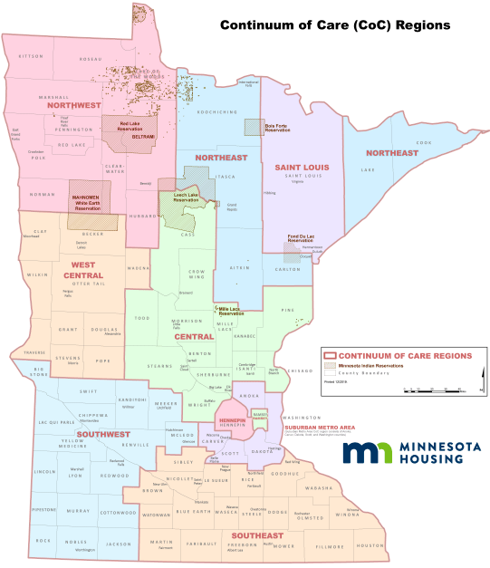

What is Permanent Supportive Housing?
Permanent Supportive Housing (PSH) is for people with disabilities. It is permanent housing with indefinite leasing or rental assistance paired with supportive services (case management, mental health services, etc.). The goal of this type of housing placement is for homeless persons with disabilities or families with an adult or child household member with a disability to achieve housing stability.

What is Transitional Housing?
Transitional Housing (TH) is intended to provide homeless individuals and families with temporary housing stability and support in order to successfully move to and maintain permanent housing in the future. Transitional Housing (TH) may be used to cover up to 24 months of housing costs with accompanying supportive services (case management, mental health services, etc.).

What is Coordinated Entry (CE)?
Housing and Urban Development’s (HUD) policy is that people experiencing chronic homelessness should be prioritized for Permanent Supportive Housing placement. The Coordinated Entry (CE) process was established by the Saint Louis County CoC in 2017 in order to ensure that people with the most severe service needs and levels of vulnerability are prioritized when it comes to receiving housing assistance. Participation in CE is a funding requirement for agencies/units receiving funding from the CoC. Households in the Saint Louis County CoC are assessed for vulnerability using the Vulnerability Index – Service Prioritization Decision Assistance Tool (VI-SPDAT, also often referred to as a SPDAT).

What is a VI-SPDAT?
The VI-SPDAT is an assessment used by most CoCs in Minnesota in order to screen PSH and TH applicants. VI-SPDATs screen for vulnerability to housing instability and/or chronic homelessness. VI-SPDAT assessments result in numerical scores that are used to place applicants on Saint Louis County’s combined waitlist for PSH/TH. This waitlist is held and managed by the Duluth Housing and Redevelopment Authority (HRA) in the Homeless Management Information System (HMIS) database. The Duluth HRA’s Coordinator of Coordinated Entry may access information in HMIS, as well as case managers involved in CE.

Saint Louis County Coordinated Entry (CE)
In Saint Louis County, residents who wish to apply for PSH and/or TH units use the CE process. The CoC’s Saint Louis County Housing Assessment Team (SLCHAT) created a process consisting of 4 main steps:

Pre-screen
Applicants contact United Way 2-1-1 and may request a pre-screen or it may be suggested to them based on what they decide to disclose to the Community Resource Specialist (CRS) they speak with. Once the applicant is pre-screened, if they are eligible to proceed through the Saint Louis County CE process, they move on to be assessed by a participating case manager using a VI-SPDAT. Referrals can be made to Saint Louis County Housing Assessment Team (SLCHAT) if information is given regarding Saint Louis County’s CE without a pre-screen being given.
Applicants use United Way 2-1-1 as a ‘front door’ to this process, but may start this process using other ‘doors’ including:
- Duluth’s CHUM homeless shelter intake form
CHUM case managers who are trained perform VI-SPDATs in-house in lieu of making appointments. They use the intake form to capture the required pre-screen information and then perform the VI-SPDAT. If the applicant is staying at CHUM, it may be good to ask if they have already spoken with a case manager during their intake at CHUM (such as Kim or Cully) to try and ensure that they are not repeating steps in the CE process. If they are unsure whether they have been assessed, it is better to schedule them for a VI-SPDAT to make sure they are put on the waitlist if appropriate.
- Duluth’s Homeless Street Outreach Team
Case managers with the Street Outreach Team are trained to perform VI-SPDATs when engaging with homeless individuals living on the street, in vehicles, or outside. If an applicant is in a living situation like this, it may be good to ask if they have already spoken with a Street Outreach Team member (such as Deb Holman) to try and ensure that they are not repeating steps in the CE process. If they are unsure whether they have been assessed, it is better to schedule them for a VI-SPDAT to make sure they are put on the waitlist if appropriate.

VI-SPDAT
Applicants are scheduled an appointment for a case manager to perform a VI-SPDAT. Most VI-SPDAT assessments are done in-person with as many members of the applicant’s household present as possible. If the applicant’s household is unable to attend a VI-SPDAT appointment in person for whatever reason, a phone VI-SPDAT may be used instead.

Waiting period
Once the VI-SPDAT is complete, the case manager submits the applicant information and score to the Duluth HRA’s CE waitlist. Wait times vary, as this is not a first-come first-served list. Applicants who score X or higher are usually placed sooner, while applicants who score X or lower may not be placed at all. It is important to keep contact information updated with this case manager, and to answer messages left by the case manager in order to be placed. If applicants forget their case manager’s name and contact information, they may contact the Duluth HRA’s Coordinator of Coordinated Entry for assistance.
If applicants are on the waitlist for an extended period of time, they may be asked to schedule another VI-SPDAT assessment in order to keep their score up-to-date.

Placement
When the applicant comes to the top of the waitlist and PSH/TH unit becomes available to them, they are contacted by the case manager who performed their VI-SPDAT. The case manager will inform them of the process they need to complete in order to be placed in the PSH/TH unit.

Identifying Eligible Residents
Saint Louis County Housing-related CE is operated through the Saint Louis County CoC and mainly assesses residents of Saint Louis County who are homeless or about to become homeless. If the applicant is eligible and seeking PSH or TH, follow the directions regarding the SLCHAT/iCarol Pre-Screen form. If not, redirect the client to more appropriate resources for their situation. This may include a referral to another CoC’s CE program, these programs are searchable in iCarol using the Housing Related Coordinated Entry taxonomy code.

Filling out the SLCHAT Pre-Screen Contact Form
After opening a 2-1-1 Call Report contact form, the SLCHAT/iCarol Pre-Screen contact form should be opened and completed within the applicant’s initial call form. The contact form should be filled out as completely as possible. Try to speak directly with the applicant in order to get firsthand information and protect the caller’s confidentiality.

Name
Please put the Head of Household’s name in this field. If the household has more than one adult in it, the Head of Household is usually recorded as the person making contact with 211.

Phone
Please put the Head of Household’s phone number in this field. If they are unable to be contacted directly by phone, they may give an alternate number for case managers to contact if their name comes up on the Coordinated Entry waitlist. Otherwise, the case manager in charge of contacting th

Zip Code
Ask the caller for the city they live in and look up a zip code for them, as it’s unlikely they have a permanent address to provide you with. If they are living between cities, ask for the city that they spend most of their time in. This will ultimately influence where their assessment is scheduled.

Contact type
Select the first method of contact used to communicate with this individual/household for reporting purposes.

Where is the applicant spending the night at this time?
Some applicants are still able to live in a house/apartment/room of their own for a short amount of time. If they are able to stay there longer than 2 weeks before they are forced to leave due to eviction, etc., then they should call back when they within 2 weeks of the date of homelessness.

Residency
Please indicate if Saint Louis County is the client’s most recent county-of-residence.

Where is the applicant spending the night at this time?
Select the closest matching housing situation in the dropdown menu. If the caller is staying in a shelter, also indicate the approximate date they entered the shelter. If they are staying outside, ensure they have information regarding their local shelters/street outreach team. If they are staying somewhere not listed in the dropdown menu, select ‘Other +’ and briefly enter information about the client’s living situation in the box that appears.

How long has the applicant been staying there?
Select the length of time that the applicant has been spending the night as indicated in the last response. This should be roughly the amount of time the applicant has been homeless/experiencing housing insecurity.

Why is the applicant seeking transitional housing?
Select the reason the household is applying for Coordinated Entry services from the dropdown list. ‘Doubled up’ means they are staying with someone else, but cannot stay permanently. Applicants that are deemed ineligible at this point, they should be directed to other resources and told to call back when they are within the eligibility guidelines for this program.

Domestic Violence
Assess whether or not the applicant is dealing with domestic violence/safety concerns and make referrals as appropriate. Check the box only if the applicant has safety concerns.

How old is the head of household
Select the age of the applicant.
If they are age 21 or younger in Duluth then efforts should be made to schedule them with Life House for their VI-SPDAT. If the applicant is age 24 or younger referrals should be made to Life House and LSS shelters/homeless youth programs.
If they are 21 or under and on the Iron Range, efforts should be made to schedule them with AEOA. If they are age 24 or under on the Iron Range referrals should be made to the AEOA Youth Foyer/Shelter.
If they are age 55 or older, they may be eligible for senior programs and should be screened as appropriate for these.

Household type
Select the makeup of the household. If there are 2 partnered adults in the household select ‘couple.’ If there are multiple adults applying as a household they might consider applying separately. Indicate if there are any children or dependents who would be living with the applicant –indicate if the applicant has these children or dependents with them currently, or if they will/hope to have them with them in the future (due to issues like custody, needing a place for them to sleep, currently being pregnant, etc.) If the head of household is age 24 or younger, select ‘Youth head of household’ as well.
If selecting the checkbox indicating that the applicant is a single individual who is transgender, be sure to mark the ‘male’ or ‘female’ box as well to indicate their how they identify –if they do not identify as male or female, only select the transgender identifier.

Number of people in household
Indicate how many people are in the applicant’s household

Military veteran in household
Indicate whether there is a military veteran in the home. If there is, an effort should be made to schedule the applicant with the Military Assistance Council for Veterans (MACV) for their VI-SPDAT assessment. Referrals to other veteran-related programs can be made as appropriate.

Appointment Information
This section should be filled in according to the date, time, and agency selected for the applicant’s VI-SPDAT assessment appointment. Select ‘pre-appointment contact’ if the applicant does not have a personal phone to call, or if you’d recommend that they are contacted for a reminder regarding their assessment appointment.

Worker’s Comments
Use this section to record any other pertinent information –such as disability accommodations that may be required to attend their appointment, alternate contact information, etc.

Example Contact Form:

Downloading form
Submit the iCarol form and then find it again under your recent contacts. Open the submitted form by Uclicking the call form number.
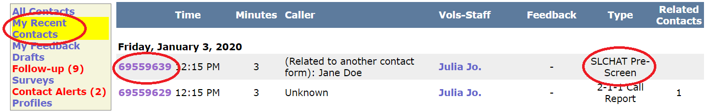
Use the ‘make PDF’ button on the right hand side of the screen to create a pdf of the SLCHAT Pre-Screen contact form.
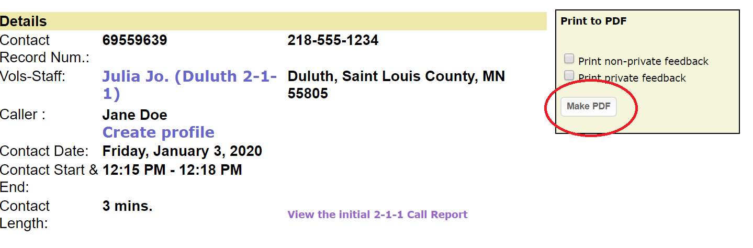

Then click ‘download pdf.’
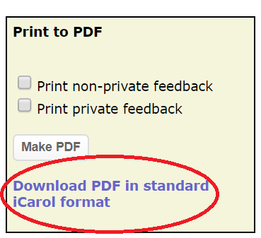
Save the pdf as ‘SLCHAT’ and the call form number (eg. SLCHAT 69550422)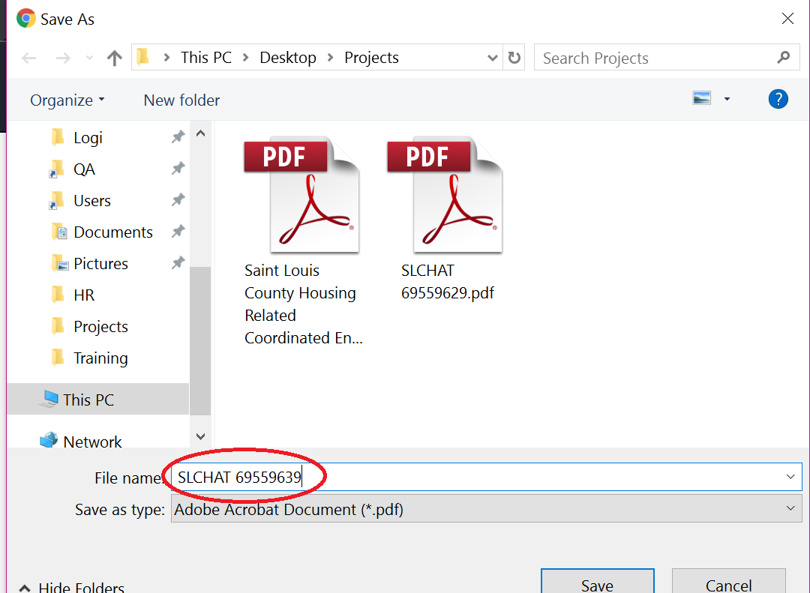

Setting an Appointment
(Process TBD)
Note:
The following agencies will only provide VI-SPDAT assessments to applicants in their target populations:
- MACV: Veterans
- Life House: Youth ages 24 and under
- Bois Forte: Native Americans

Agencies with VI-SPDAT-trained case managers currently accepting CE appointments:

Duluth
- Salvation Army
- Life House (youth ages 21 and under only)
- MACV (veterans only)

Nett Lake
- Bois Forte (Native Americans only)

Virginia
- AEOA
- Range Transitional Housing

Hibbing
- AEOA
- Range Transitional Housing

Agencies with VI-SPDAT-trained case managers not currently accepting CE appointments:

Duluth
- Human Development Center - HDC

Hibbing
- Range Mental Health

Virginia
- Range Mental Health

Setting Client Expectations
Review the following with the applicant:
- This is not a process for emergency housing. Coordinated entry is for transitional and permanent supportive housing units. These are usually not readily available, and there are hundreds of households on the waitlist at any given time. It is usually a good idea to suggest that clients pursue other ideas for housing in the meantime, and/or give out local homeless shelter information so they can make arrangements in the meantime.
- The waitlist order is determined by each household’s assessment score. With new households being added to the list frequently, and scores being variable, it is not possible to estimate or predict when or if households will be placed through this process.
- 211 does not have access to the waitlist, the Duluth Housing and Redevelopment Authority – HRA holds this waitlist, callers with questions can be directed back to their assessing case manager, or be given the Coordinator of Coordinated Entry’s contact information.
- Clients must attend their VI-SPDAT appointment in order to be placed on the waitlist. Simply calling 211 and doing a pre-screen will not establish them on the waitlist.

Missed Appointments
If a client missed their appointment, they should contact the case manager they were scheduled with in order to reschedule. Sometimes a case manager will ask that the client call us back to reschedule. In this case, try to help the caller access another appointment on the calendar.

Complaint Process
Complaints about the Coordinated Entry process are handled by the client’s case manager. If the complaint is regarding the case manager, or the client does not wish to funnel the complaint through the case manager, they can contact the Coordinator of Coordinated Entry to make a complaint. 211 is not able to take complaints or make changes to the official process, CSRs prescreen and set initial appointments only.

Contacts

Iron Range CoC Contacts

Legal Aid of Northeastern Minnesota
- Paralegal/Housing Advocate - Heather Lindula (218) 749-3270 ext 403 hlindula@lasnem.org

Range Transitional Housing
Virginia
- Case Manager - Jessie Kowarsch (218)735-6321; Jessie@rthousing.org
- Case Manager - Gretchen Ray (218)741-9628; Gretchen@rthousing.org
- Case Manager - Nate Fredrickson (218)750-4785; nate@rthousing.org

Hibbing
- Case Manager - Monica Plombon (218)263-9250; monica@rthousing.org
- Case Manager - Jennifer Bastianelli (218)263-9250; Jennifer@rthousing.org

AEOA
- Homeless Services Case Manager - Caitlyn Rinell (218)290-5419; Caitlyn.rinell@aeoa.org
- Homeless Services Case Manager - Courtney Lake (218)263-8487; Courtney.lake@aeoa.org
- Homeless Services Case Manager - Hannah Barnes (218)290-8481; Hannah.barnes@aeoa.org

Range Mental Health
- Homeless Services Case Manager - Noel Koskela (218) 749-2881; nkoskela@rangementalhealth.org

Bois Forte
- Homeless Program Case Manager - Tracey Howg (218) 757-3295; – thowg@boisforte-nsn.gov

Duluth CoC Contacts

Duluth HRA
- Coordinator of Coordinated Entry - Kate Bradley (218) 529-6300; KBradley@duluthhousing.com

CHUM Homeless Shelter
- Case Managers performing VI-SPDATs – Kim Randolph and Cully (218) 726-0153 ext 211; chum@chumduluth.org kimr55760@gmail.com

Saint Louis County Public Health and Human Services
- Homeless Programs Planner – Stacy Radosevich (218) 726- 2543; radosevichs@stlouiscountymn.gov

Duluth Street Outreach Team
- Street Outreach Case Manager - Deb Holman (218) 461-8505; dholman@chumduluth.org

MACV
- Case Manager - Jon Livingston (218)722-8763; jlivingston@mac-v.org

Life House
- Senior Housing Case Manager - Tiffany Gunderson (218)722-7431 ext 116; tiffany.gunderson@life-house.org

Salvation Army
- Housing Case Manager - Kim Holak (218)722-7934; kim_holak@usc.salvationarmy.org

Maps of Saint Louis County Assessor Cities

South Saint Louis County - Duluth
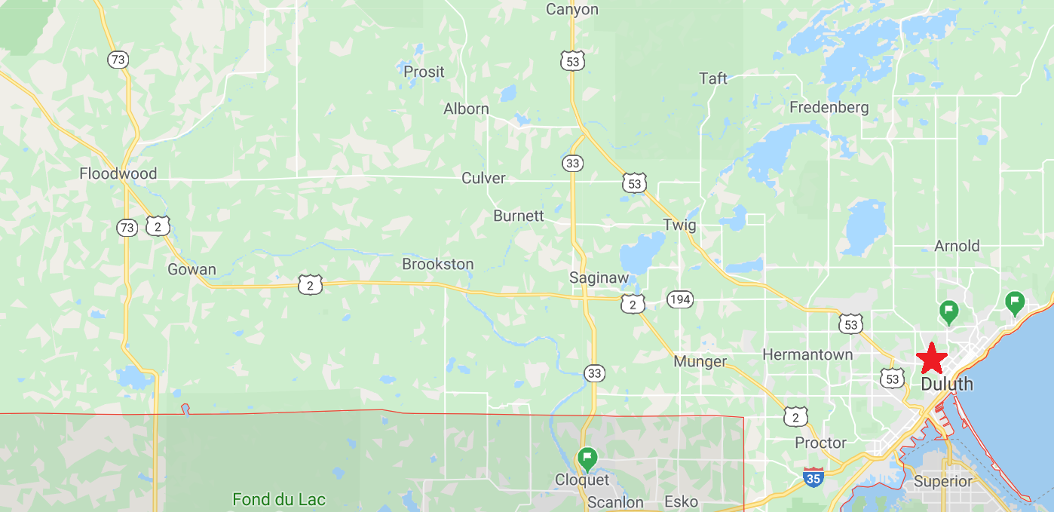

North Saint Louis County – Hibbing, Nett Lake, Virginia
