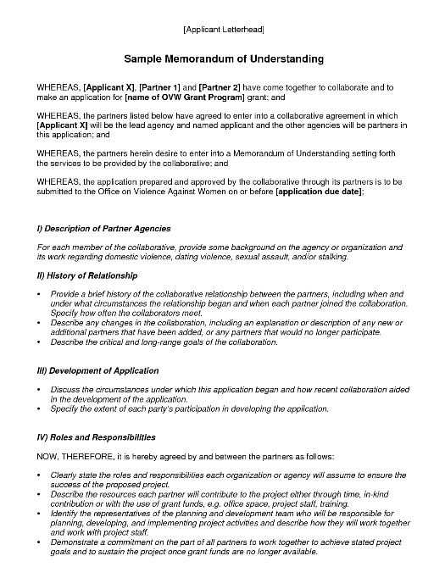
University of MN School of Social Work, hereby agrees to the provide a Master of Social Work Student to assist with the following CoC Planning activities:
- Coordinate volunteers, collect data and provide a report on results for the annual point in time count
- Participate in monthly leadership meetings and take meeting minutes
- Assist CoC leadership with evaluating individual projects performance and outcomes
- Assist CoC leadership with facilitating or co-facilitating subcommittees

A student intern will be assigned to the CoC during the 2019-2020 school year. They will volunteer for a total of 400 hours from September 2019-May 2020 at a rate of $26.89 per hour. This hourly rate was determined by the Independent Sector which estimates the values of each volunteer hours and aligns with the rate for this position with other agencies salaries for a similar position outlined in this MOU. The rate above was the per hour rate for Minnesota in 2018. If rate should increase during our intern’s time, we will communicate that change. The value of this in-kind volunteer opportunity is $10,756 (400 hours x $26.89 per hour).

COC HUD grant MN0000L5K031800
Sample Memorandum of Understanding for Services

Stratus Consulting Inc, will provide the following in-kind match to support the CoC Coordinator position from 9/1/2019-08/30/2020:
- Office rent- $25 per square foot x 120 per year
- Office phone-$41.66 per month x 12 months
- Computer-$125 per month x 12 months
- Mileage- use of agency vehicle $.58 per mile x 5000 miles
- Office supplies, printing, copying and postage- approximate value $1250 (our organization will assign a code to Coordinator to track all expenses

The value of this in-kind good contribution is $9,250. Our agency will assign a budget code for this commitment and the staff will use code to track use of items outlined above.

Quarterly reconciliation will be conducted and submitted to the CoC Coordinator to track in-kind match.

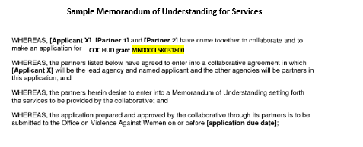
Stratus Consulting Inc, will provide the following in-kind match to support the CoC Coordinator position from 9/1/2019-08/30/2020:
- Office rent- $25 per square foot x 120 per year
- Office phone-$41.66 per month x 12 months
- Computer-$125 per month x 12 months
- Mileage- use of agency vehicle $.58 per mile x 5000 miles
- Office supplies, printing, copying and postage- approximate value $1250 (our organization will assign a code to Coordinator to track all expenses

The value of this in-kind good contribution is $9,250. Our agency will assign a budget code for this commitment and the staff will use code to track use of items outlined above.

Quarterly reconciliation will be conducted and submitted to the CoC Coordinator to track in-kind match.

Signature & Date Signed

Signature & Date Signed

